

PROGRAMMING TECHNIQUES

Homework 1

Student : Tudor Vlad Bresan
Group: 30423
Table of Contents
Homework 1 1
1 Problem specification 3
2 Problem analysis, modeling, scenarios, use cases 3
2.1 Problem analysis 3
2.2 Modeling 4
2.3 Scenario and use cases 4
3 Design 6
3.1 UML Diagram 6
3.1.1 OneTermOp Interface 7
3.1.2 TwoTermOp Interface 7
3.1.3 Polynom Class 7
3.1.4 GUI Class 7
3.1.5 OpWith1Term Class 8
3.1.6 OpWith2Terms Class 8
3.1.7 Main Class 9
3.2 Data Structures 9
3.3 Relationships 9
3.3.1 Algorithms 9
3.3.2 User Interface 11
4 Implementation and testing 12
5 Results 13
6 Conclusion and feature development 14

Problem specification
Homework number 1 – Propose, design and implement a system for polynomial processing. Consider polynomials of one variable and integer coefficients.
The program will be able to perform 9 operations on polynomials (operations on one polynomial or operations on two polynomials), which are:
- Derivation of one polynomial
- Integration of one polynomial
- Evaluation at a specific point X of a polynomial
- Definite integral of a polynomial
- Addition of two polynomials
- Substraction of two polynomials
- Multiplication of two polynomials
- Division of two polynomials
- Testing the equality of two polynomials
The program will have a graphical user interface so that the user will be able to insert polynomials and then select the desired operation for one of the polynomial or for both of them.For the evaluation at a specific point X , the user has to input the desired value. The same goes for the definite integral of a polynomial, the user has to input the desired values a and b. The Graphic User Interface(GUI) will contain different buttons for each operation the user wants to perform .Whether that specific operation is commutative or not the user will still be able to select which way the operation will be performed. Also, the user can edit at any time the polynomials that he or she entered and clicking the Submit button afterwards. The result of the operation will be shown near the message “Output”.

Problem analysis, modeling, scenarios, use cases

Problem analysis
A polynomial can be modeled inside an application in several ways. The simplest of them all , yet a real interpretation , would be to store the coefficients into an array , their position being decided by the exponent which is going to be the index of that array.Each time an operation is performed creates a new polynomial and returns either a polynomial , a value or a true/false value, depending on the operation the user has selected.

Modeling
The implementation of this project is going to be done as follows : operations will be divided in 2 classes , a class that is going to hold all the methods that are meant to be performed on one polynomial and a class that is going to hold all the methos that are meant to be performed on two polynomials, these two classes that hold the operations methods will implement an interface; besides these two classes and the two interfaces we’ll have another class Polynom that is going to create the polynomial, transform it from user input(String) to the program’s interpretation of a polynomial (object) ; the last class GUI will provide the user the means of inputing polynomials and manipulate them.

Scenario and use cases
The user can enter as input the polynomials in the following format “1x^2+2x^1+3x^0”. The monomials can be entered in any order as long as the format remains the same “coefficient*x^power”. The introduced polynomials will not be altered by any operation and can be changed at any time as long as after that change happens the users clicks the submit button.If a text field of a polynomial is left blank that polynomial will be considered the zero polynomial. For derivation ,integration , evaluation and definite integral the user can choose to perform the operation on either one of them , it’s the users call. As for substraction and division the user can chose which way the operation is going to be performed (p1-p2/p2-p1 , p1/p2 or p2/p1).
As a particular case for the division , integration and definite integral even though the polynomials have integer coefficients , the result will have real coefficients . I chose this solution to treat all cases.

DATA IN
UPDATE

SUBSTRACTION

MULTIPLICATION

ADDITION
PROGRAMMER

DIVISION

COMPARISON

USERS
DIFFERENTIATION
MAINTENANCE

INTEGRATION

EVALUATION

DEFINITE
INTEGRATION

Design

UML Diagram
The UML diagram is a class diagram in which we can find the relationship between classes and also the elements(class variables , methods) a specific class contains.
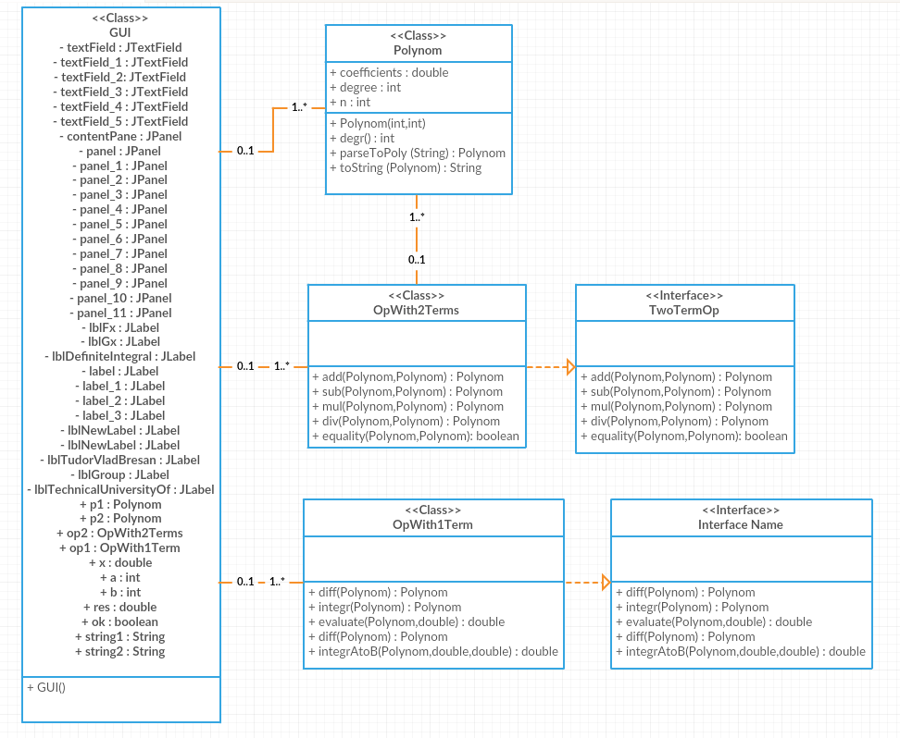

OneTermOp Interface
The OneTermOpInterface , as the name is suggesting , it’s showing the “behavior” of the class OpWith1Term. All the methods with empty bodies are going to be implemented in the class mentioned here (3.1.1)

TwoTermOp Interface
The TwoTermOp Interface , as the name is suggesting, it’s showing the behavior of the class OpWith2Terms. All the methods with empty bodies are going to be implemenented in the class mentioned at this point(3.1.2)

Polynom Class
The Polynom class is the class where each monomial is added to the previous one , if they are meant to be in the same polynomial. This class consists of 3 methods and the constructor. The constructor (as it’s name suggests) , constructs the polynomial . The 3 methods implemented insde this class are the following : degr ( this is method that returns the degree of the polynomial), parseToPoly (this is a method that is getting as argument a String , that the user enters, and returns an object of type Polynom which is later going to be used) and toString method (this method gets as argument an object of type Polynom and it returns a printable format of it, more precisely a String.

GUI Class
This class is designed to create a graphical user friendly interface to simplify the use of the application. This class is a subclass JFRame for the purpose of using objects like : buttons , frames, textfields, panels.
This class has only a constructor which initializes everything that is meant to be seen by the user and for each action that the user performes it has a piece of code that handles that action accordingly.Therefore this class is linked with classes like OpWith1Term, OpWith2Terms , Polynom and Main. The result of running the constructor of this class will be shown on the screen. The GUI is the “middle-man” between the common user and the code.
Observe the 2 text fields that are shown at the top of the graphic user interface. These two text fields represent the input of the two polynomials . Also , at the bottom of the graphic user interface an output field can be observed , each time an operation is performed , the result will be printed in that field. We also can observe the buttons which are given names or symbols according to their purpose, there are some other text field which are meant for input of some other data like the x for evaluation of a polynomial.

OpWith1Term Class
Within OpWith1Term Class you can find all the operations that can be applied to a single polynomial. This class has no constructor and it implements the following methods:
- Differentiation of one of the polynomials : it returns a polynomial after differentiating the polynomial that was sent as argument
- Integration of one of the polynomials : it returns a polynomial after integrating the polynomial that was sent as argument
- Evaluation of one of one of the polynomials : it returns a real value after computing the polynomial’s value at point x which is sent as argument besides the polynomial to be evaluated
- Definite integration of one of the polynomials : it returns a real value after computing the definite integral from a to b . This method receives as arguments an object Polynom and two real values : a and b.

OpWith2Terms Class
Within OpWith2Terms Class you can find all the operations that can be applied on two polynomials . This class , has a similar pattern with the OpWith1Term Class due to the fact that it has no constructor and it implements methods that are meant for two polynomials instead of one. The methods implemented in this class are:
- Addition of two polynomials : it returns a new object Polynom after adding the coefficients of the two polynomials based on their power (exponent). It receives as arguments two objects of type Polynom.
- Substraction of two polynomials :it returns a new object Polynom after substracting the coefficients of the second polynomial from the coefficients of the first polynomial, based on their power (exponent) . It receives as arguments two objects of type Polynom
- Multiplication of two polynomials : it returns a new object Polyno after multiplying each of it’s coefficients with the other’s polynomial coefficients , the exponents for those coefficients being summed when the coefficients multiply with eachother. It receives as arguments two objects of type Polynom.
- Division of two polynomials : it returns a new object Polynom after dividing successively the first polynomial with the second polynomial . The division is done until the first polynomial can no longer be divided . It receives as arguments two objects of type Polynom.
- The equality method : it returns a Boolean value after comparing the coefficients of the two polynomials based on their exponents (indexes should be equal). If the coefficients match that means that the two polynomials are identical. If at least one of the coefficients are not equal to eachother the method will return “false”.

Main Class
The main class purpose is to create a new object of type GUI . This creation is being made in the main method “public static void (String[] args) which makes the whole application run. When the new object is created the interface will pop on the screen and the application will be ready to use.

Data Structures
The main reason for using arrays in this project is the fact that , to store information , arrays are the most simple way of doing this for a polynomial.

Relationships
To solve the problem specifications the program uses 4 classes and 2 interfaces , so it can be more clear and be understood better . The name of the classes are representative and they do exactly what they’re supposed to be doing .
There are dependencies between the classes of this project, which means that a class uses another class methods or objects . The hierarchy is at follows : the class main creates a new GUI object which means it uses the GUI class. Each time a button is pressed on that interface an action listener will be ran . In that action listener we’ll have pieces of code that are specialized in executing the commands that are supposed to be executed when a specific button is pressed . That being said , a link to the other classes appear, GUI uses methods from the two classes that implement the operations , OpWith1Term and OpWith2Terms . GUI class also uses the “reading” and the “writing” methods from the Polynom class , parseToPoly and toString..

Algorithms
Addition of two polynomials. This method performs the additon of two polynomials. It adds the coefficient for a specific expoenent (index) with the coefficient of the second polynomial which is on the same index as the coefficient from the first polynomial . The sum of for each index will form a new polynom object which is going to be returned.
Substraction of two polynomials. This method performs the substraction of two polynomials. Firstly it "copies" the first polynomial to another polynom object which is going to be returned. After the object that is to be returned has the same values with the first polynomial it substracts the second polynomial given as argument from the polynomial that is to be returned.

Division of two polynomials. This method performs the division of two polynomials. In case the the 2nd polynomial is the zero polynomial it will thrown a division by zero exception. It willl also throw an exception if the degree of the second polynomial greater than the degree of the first polynomial. The algorithm works as follows: it takes the monomial with the highest exponent of the first polynom and it divides it's coefficient to the coefficient of the highest monomial. The result is the coefficient of the monomial with the exponent given by substracting the exponent of the second monomial from the exponent of the first monomial. This step is perfomed in a while loop until the degree of the first polynomial is lower than the degree of the second polynomial . Each time a division of two monomials is performed the product of the resulted coefficient with each coefficient of the second polynomial is substracted from the first polynomial , this way the division is perfomed until a division can no longer be performed. The method takes 2 arguments of type Polynom and returns a Polynom object.
Multiplication of two polynomials.It's a method that takes as input arguments two objects of type Polynom and returns a Polynom. The algorithm is composed of a nested for statement which multiplies each coefficient of polynomial 1 with each coefficient of the second polynomial. If the indexes(exponents) match the coefficients for that specific exponent are added together.
Check if the two polynomials are identical. This method takes as input arguments two objects Polynom and returns true if the two objects hold the same values of coefficients for the exponents. It returns false is they are not the same .
The diff method implements the differentiation of a polynomial. It takes as an argument an object Polynom and returns an object Polynom named deriv. The for loop starts at the lowest index which represents the term with x^0 and from there it builds the derivative by multiplying the exponent with the coefficient. Ex: 2x^4 will become 4(exponent, i+1 )*2(coefficient, coefficients[i+1])*x^3(the new index i)
Antiderivative method is the exact oposit of the differentiation. It takes as an argument an object Polynom and returns an object Polynom named integral. the for loop starts ath the highest index which represents the highest degree and it gives the value of the coefficient by the following formula : coefficient i+1(power of x, x^i+1) gets the value of the result given by the coefficient i divided by i+1.
Value of polynomial at point x method takes as arguments an object Polynom and a double value x. It returns a double named val which represent the result of the polynomial by replacing the X(variable x of polynomial) with the given value of x !
Definite integral from a to b . This method returns a double named val and it takes as arguments an object Polynom and two boundaries a and b(double) It computes the integration and then evaluates the integral in point a and b the result is given by substracting the result given by evaluating the integral in a from the result given by evaluating the integral in point b.

User Interface

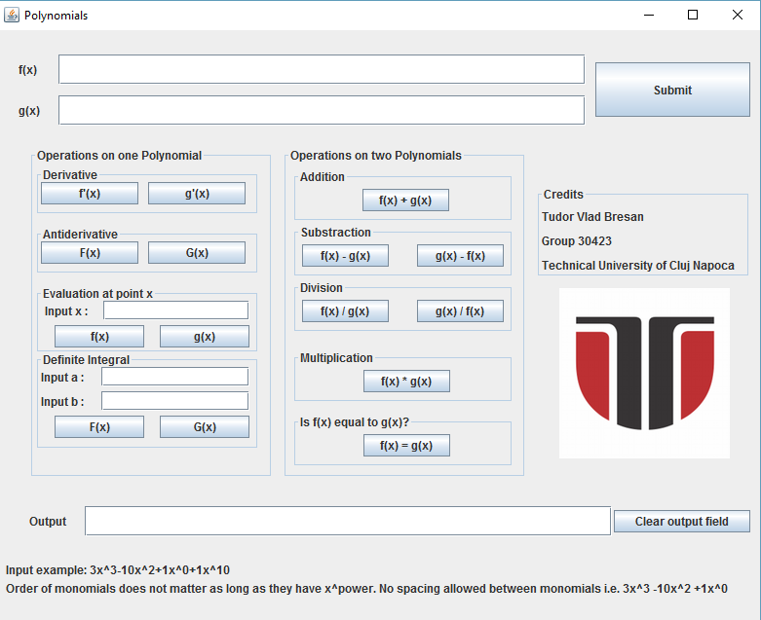

In order to input a polynomial , the user needs to enter the polynomial is a specific format in the designated space . The format applies for both polynomials and it’s like this : “2x^3+1x^1+3x^0-6x^12”. The order of the monomials does not matter and that gives the liberty of editing anytime without erasing what it is aleady written . Every time a change has been made , the user has to click the submit button in order for the changes to take place. Each operation that can be performed on on polynomial it has the option of choosing the polynomial. As for the operations performed on two polynomials there are some cases when the operation is not commutative and buttons have been added to choose the desired order for those operations that are not commutative. Each time a button is pressed the output will be written in the text field with the label “Output”.
If the user has finished inputing the polynomials , he can use one of the buttons to perform some operations but in order to use more complex operations that need extra input values the user has to input those values in order for the computer to be able to perform those operations as well. So , for the evaluation of a polynomial at a point x the user has to input x ,and for the definite integral the user has to inpute the start value and the end value of the integral , meaning the values for a and b.

Implementation and testing
In order to store polynomials that the user inserts into the application, an array of coefficients is being used. This is how the array in constructor Polynom is being built:
public Polynom(int coeff, int power) {
coefficients = new double[power + 1];
coefficients[power] = coeff;
degree = degr();

Even though most of the methods in OpWith1Term and in OpWith2Terms have identical parameters , each one of them does it’s own job. The header is almost the same for all the methods due to the fact that they all get either one or two polynomials .Here’s an example of a header and it’s call.
Public Polynom div(Polynom p,Polynom q)
Rez = op2.div(p1,p2);
Here are a few details about the more complex operations :
Mutiplication is very simple , it just multiplies the coefficients of the two polynomials and returns them on the summed index of a new polynom object.
R[i+j] += p[i]*p[j]
The division goes through a series of comparisons and loops , every iteration being different from the previous one . The comparison is necessary to verify that the degree of the first polynomial is still greater than the degree of the second polynomial. If a division is performed on one step , the value of p1 changes.
While (p.degree >= q.degree){…}
The definite integral is not so complicated . It uses two methods that are implemented and it makes it look so easy when you just have a glimpse at the code. The logic behind the definite integral is that it calls the method integr which integrates the polynomial and after that it substracs the value returned after calling the method evaluate for the integrated polynom and value a from the value returned by calling the evaluate for the integrated polynomial and value b.
Integral = integral(p);
Val = evaluate(integral,b) – evaluate(integral,a);
Return val;

Results
Let us assume the users enters the following polynomials :
f (x) = 3x^2+5x^1+2x^0
g(x) = 2x^1+1x^0
For every operation we will have the correct result :
- f + g : 3x^2+7x+3
- f – g : 3x^2+3x+1
- g – f :-3x^2-3x-1
- f / g : Quotient: 1.5x +1.75 Remainder: 0.25
- g / f : Invalid operation. Division by 0 or grade of f(x)> grade of g(x)
- f * g : 6x^3 + 13x^2 + 9x + 2
- f ?=g : false
- f’(x) : 6x +5
- g’(x) : 2
- F(x) : x^3 + 2.5x^2 + 2x
- G(x) : x^2+x
- For x = 3 we evaluate
- f (3) : 44.0
- g(3) : 7.0
- For a = 1 and b = 4 we integrare
- For f : 106.5
- For g : 18.0

Conclusion and feature development

I have improved my oop skills and learned new things like using interfaces . We can improve my current project :
- Making it easier for the user to input data
- Adding more operations
- Make the buttons unavailable until the user input the data
- Make the reading and writing of polynomials easier
- Make the reading and writing of the polynomials more general

